ECS[TASK-01]

**Setup a highly available ecs cluster with load balancer and dynamic port mapping.**

**NOTE:  
Your cluster should maintain atleast 6 tasks at any point of time and should be highly availble across multiple AZ's.  
Use the below image from deployment:  
sabair0509/hiring-app:works**

* Created a ecs cluster

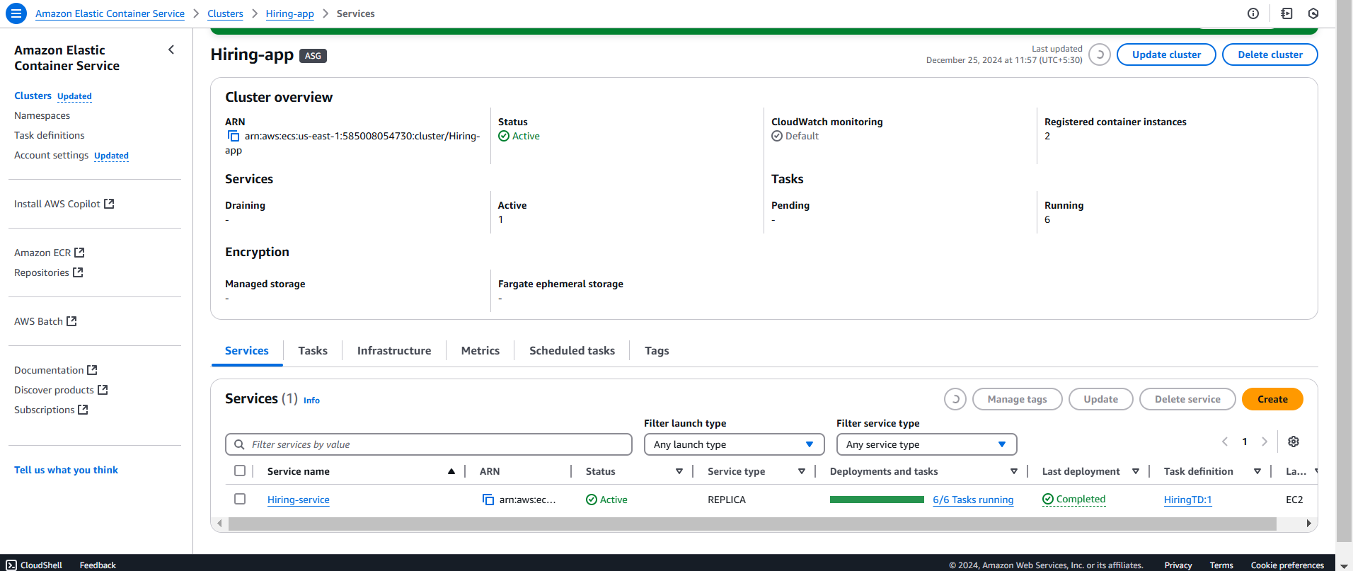

Created application load balancer with the target instances

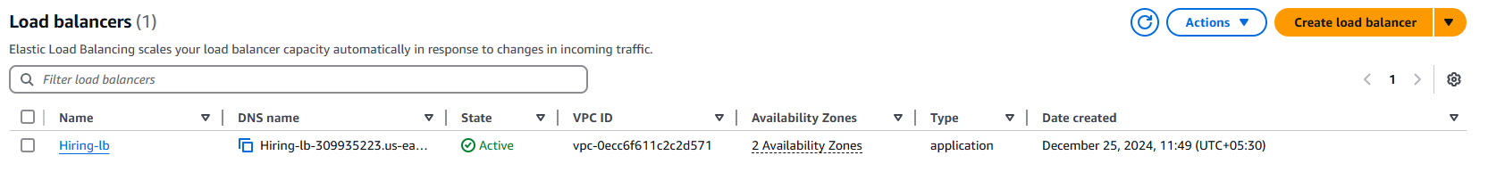

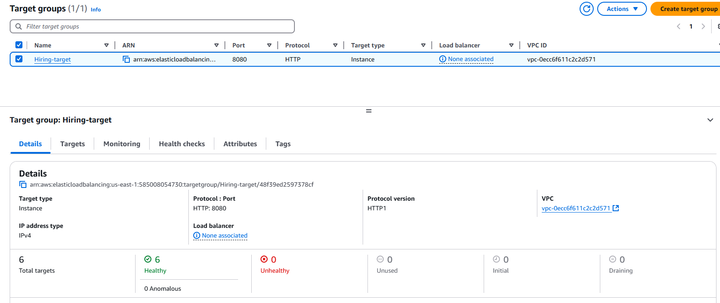

Created a Task defination

